Contents

Basic Topics in C++ 3

Operators 3

Scientific decimal places in number calculations 3

C++ References 3

C++ Pointers 3

C++ Data Structures Implementation 3

C++ Object Oriented Detailed Notes 3

C++ Class Members 3

C++ Friend Classes and Functions 3

Operator Overloading 4

Operator + 4

Operator - 4

Operator * 4

Operator / 4

Operator == 4

Operator -- 4

Operator ** 4

C++ 4

Figure 0—1: Addition and Substruction of Integers in C++ 3

Figure 0—1 4

# Basic Topics in C++

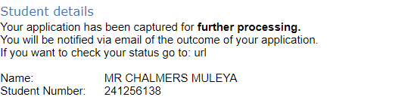

Figure 0—1: Addition and Substruction of Integers in C++

## Operators

## Scientific decimal places in number calculations

# C++ References

# C++ Pointers

# C++ Data Structures Implementation

# C++ Object Oriented Detailed Notes

# C++ Class Members

## C++ Friend Classes and Functions

# 

# Operator Overloading

Figure 0—1

## Operator +

## Operator -

## Operator *

## Operator /

## 

## Operator ==

## Operator --

## Operator **

# C++